Poverty and Social Exclusion

EAPN calls for a strong European Pillar of Social Rights with real impact! We need a new paradigm – a transformative EU strategy that invests in social rights and reduces poverty and inequality! #LastChance4SocialEurope #SocialRights

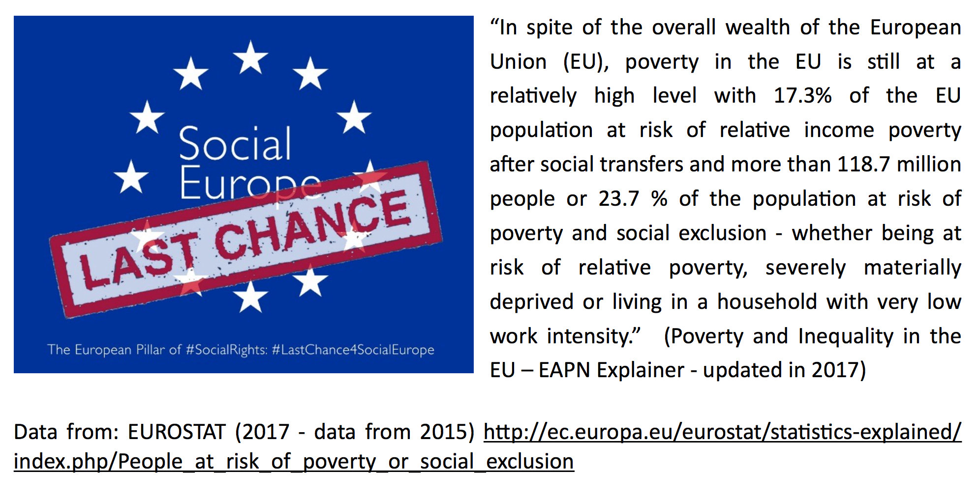
#LastChance4SocialEurope We need a new paradigm, a transformative EU strategy that invests in #SocialRights & reduces poverty and inequality

